

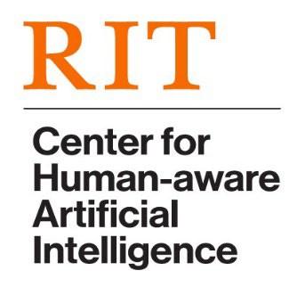

CHAI Seminar Series

*RIT only event. Refreshments will be served.*

# **DATE:** Monday, October 24, 2022, 12:00-1:00 PM

**SPEAKER:** Philip J Smith, PhD

Professor of Integrated Systems Engineering, The Ohio State University

**TITLE:** **Human-Automation Interaction: Making Brittle Technologies Useful**   
**IN PERSON: Golisano Hall, Room 2400**

**ABSTRACT:** Considerable research is needed to better understand how to integrate advanced technologies into human-centered system designs to take advantage of techniques made available by fields such as artificial intelligence (AI) and machine learning (ML). It also requires an understanding of the strengths and limitations of different technological approaches not only in terms of the underlying computational methods, but also in terms of effective interaction with the human users. This talk will start with the premise that, regardless of the underlying technology, the complexity of many important applications ensures that there will be boundary conditions that limit the competence of the software, often in unknown ways. To deal with this, human-centered designs need to be considered in order to provide one type of safety net, including a recognition that automation has the potential to strongly influence the cognitive processes of the user. And more advanced designs need to go beyond providing simple decision support and consider how to support effective teaming. The talk will then focus on three concepts:

* Unobtrusive interaction designs need to be developed that allow the software to infer the cognitive processes of the human user in order to support interactive critiquing.
* Information displays by the automation can have a profound impact on the cognitive processes of the user, potentially biasing situation assessment and causing hypothesis fixation, negatively impacting teamwork between automation and the user(s).
* Explanatory AI has the potential to unintentionally act as a con artist, negatively influencing the ability of the user to make effective use of his/her expertise as a team member.

To address these concepts, new interaction designs are required to support effective *cooperative* problem solving.

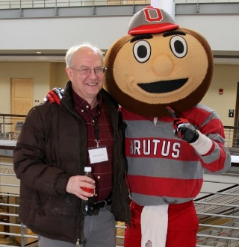**BIO:**  **Philip J. Smith, Ph.D.** is Professor in Integrated Systems Engineering at The Ohio State University and is a Fellow of the Human Factors and Ergonomics Society. His research focuses on cognitive systems engineering, human-automation interaction, the design of cognitive work systems and continuous adaptive planning. Among others, he and his students have received awards for “Best Paper” in *Human Factors* (on the design of interactive critiquing systems); the Airline Dispatchers Federation "National Aviation Safety Award"; Best Paper Award, Air Traffic Control Association Conference; and the Air Traffic Control Association David J. Hurley Memorial Award for Research in Collaborative Decision Making. His most recent research projects include:

* FAA: Human-Automation Teaming: Unintended Impacts and Mitigations for Degraded NextGen Operations
* NSF: Clinical Skill Acquisition, Retention and Atrophy with Artificial Intelligence Aids
* FAA: Best Engineering Practices for Automated Systems

[**https://www.rit.edu/chai/**](http://www.rit.edu/chai/)